Child’s name: _____________________________________



1. Type ttrockstars.com into your browser’s address bar.
2. Log in. Your child’s details are as follows:

Username: ____________________________

Password: ____________________________

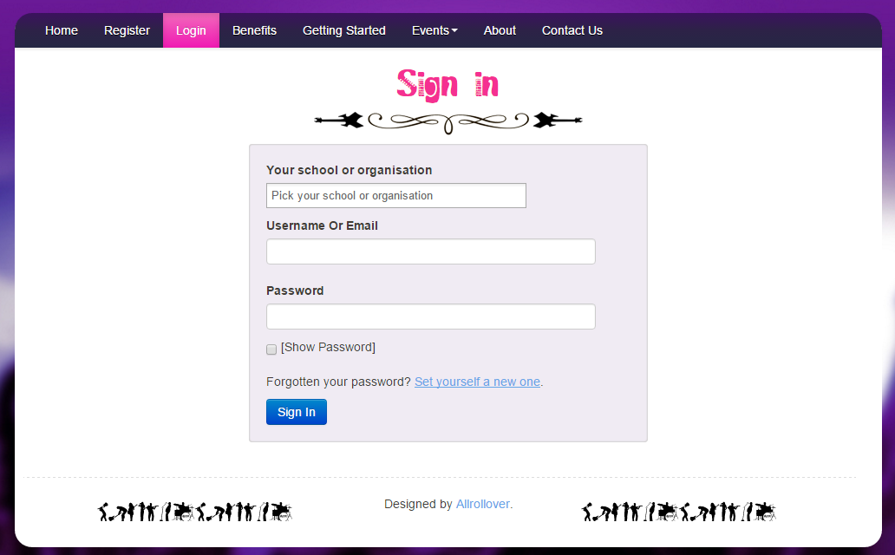

Password goes here

Username goes here

School goes here

1. Play!  
   There are 4 different game modes, which you can find out about on the back.

Game Modes

**Single Player** https://ttrockstars.com/css/singleplayer.png

**Garage** - the questions will only come from the times tables the teacher has set for the week. As pupils start to answer questions, TT Rock Stars works out which facts they take longer on and will give them more of these questions to answer. The Garage is best for getting quicker at a few facts. Players get 10 coins per question.

**Studio** - the questions in the Studio can be anything from 1×1 up to 12×12.   
TT Rock Stars calculates each the mean speed from their last 10 games in the Studio and translates into a Rock Status:

|  |  |
| --- | --- |
| ≤ 1 sec/qu = Rock Hero  ≤ 2 secs/qu = Rock Legend  ≤ 3 secs/qu = Rock Star  ≤ 4 secs = Headliner  ≤ 5 secs/qu = Support Act  ≤ 6 secs/qu = Breakthrough Artist | ≤ 7 secs/qu = Unsigned Act  ≤ 8 secs/qu = Gigger  ≤ 9 secs/qu = Busker  ≤ 10 secs/qu = Garage Rocker  > 10 secs/qu = Wannabe |

They earn 1 coin per question and the Studio is the place for them to set their best time across all the tables.

**Multiplayer** https://ttrockstars.com/css/multiplayer.png

**Rock Arena** - The Arena allows players to compete against all other members of their Band (their Bandmates would need to join the same game in order to compete together).   
A new Arena game starts every 15 seconds and once the clock starts they race to answer more questions than the others. In the Arena, questions will only come from the times tables the teacher has set for the week, similar to the Garage. They earn 1 coin per correct answer.

**Rock Festival** - The Rock Festival games are open to players from around the world. Like the Arena, there is no limit to the number of players who can join a game; however, unlike the Arena, questions are selected at random from 1×1 to 12×12.   
Pupils might choose the Rock Festival if they were playing at home (and therefore couldn't easily synchronise playing against a classmate) or wanted to compete against others not in their Band. They earn 1 coin per correct answer.

The times tables to practice

As a rough guide, these are the tables to practice according to the year group of your child.

**Year 2** – 2s, 5s and 10s

**Year 3** – 3s, 4s and 8s

**Year 4** – 6s, 7s and 9s

**Year 5** – 11 and 12s

**Year 6** - All

Please bear in mind that each school, each class and each child is different.

Stats

If you click on Me > My Stats, a heatmap like the one below will load. It shows how successful your child is at each of the facts.

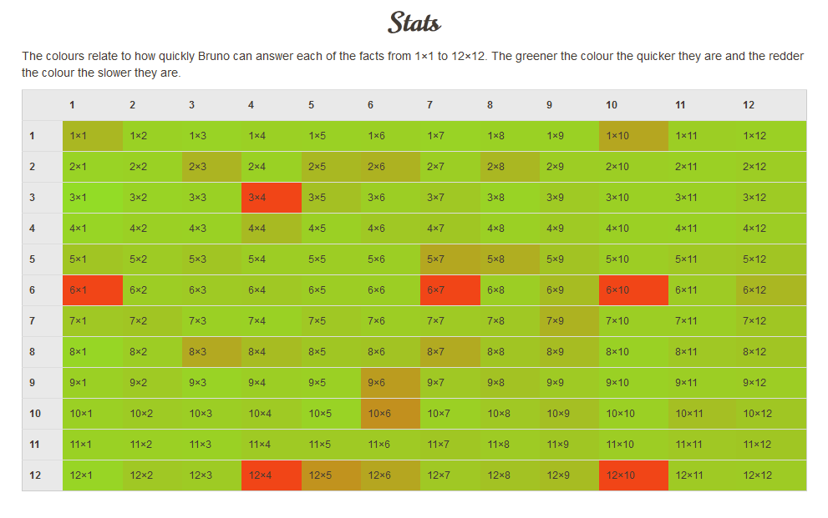

Questions, Problems, Suggestions

Contact your child’s teacher if…

* You have username or password issues
* Something isn’t working or you’re not sure how it works
* You have a complaint or a suggestion
* You have something nice to say about ttrockstars.com!

Enjoy!

